Matrix Chain Multiplication Program
#include<stdio.h>
#include<conio.h>
long int m[20][20];
int s[20][20];
// Function printParenthesis() is used for printing the optimal
// multiplication sequence of a matrix chain product
void printParenthesis(int i, int j,int s[][20])
{

// If only one matrix left in current segment
if (i == j)
{
printf("A%d",i);
}
else
{
printf("(");

// Recursively put parenthesis around subexpression
// from i to s[i][j].
printParenthesis(i,s[i][j],s);

// Recursively put parenthesis around subexpression
// from s[i][j] + 1 to j.
printParenthesis(s[i][j]+1,j,s);

printf(")");
}
}

// Matrix Ai has dimension p[i-1] x p[i] for i = 1..n
void matrixChainOrder(int p[], int n)
{
long int q;
int L,i,j,k;
/* m[i,j] = Minimum number of scalar multiplications
needed to compute the matrix A[i]A[i+1]...A[j] =
A[i..j] where dimension of A[i] is p[i-1] x p[i] */

// cost is zero when multiplying one matrix.
for (i=1; i<=n; i++)
m[i][i]=0;

// L is sub chain length.
for (L=2; L<=n; L++)
{
for (i=1; i<=n-L+1; i++)
{
j = i+L-1;
m[i][j] =20000; // 20000 is a big value inplace ofinfinity
for (k=i; k<=j-1; k++)
{
q = m[i][k] + m[k+1][j] + p[i-1]*p[k]*p[j];
if (q < m[i][j])
{
m[i][j] = q;

// Each entry s[i,j]=k shows
// where to split the matrix product
// i,i+1....j for the minimum cost.
s[i][j] = k;
}
}
}
}

printf("Optimal multiplication sequence is : ");
printParenthesis(i-1,j,s);
printf("\nMinimum number of multiplications is: %ld ", m[1][n]);
}

void main()
{
clrscr();
int p[20],n,t;
printf("Enter the number of matrices\n");
scanf("%d",&n);
printf("Enter the dimensions of the matrices\n");
for(t=0;t<=n;t++)
scanf("%d",&p[t]); // p[] contains dimensions of the matrices
matrixChainOrder(p,n);
getch();

}

Output 1:
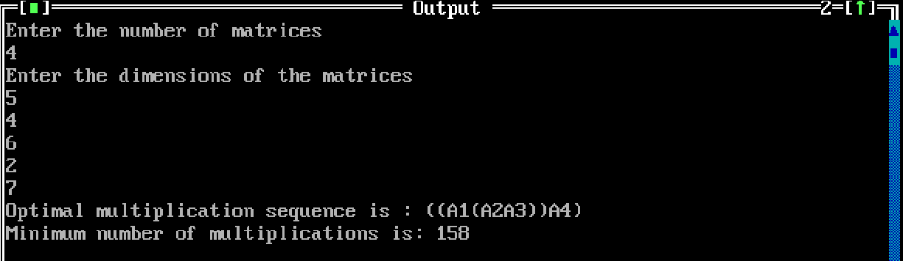

Output 2:
